Agenda Item : 2/04

= application site



Nower Hill High School, George V Avenue, Pinner | P/1190/20

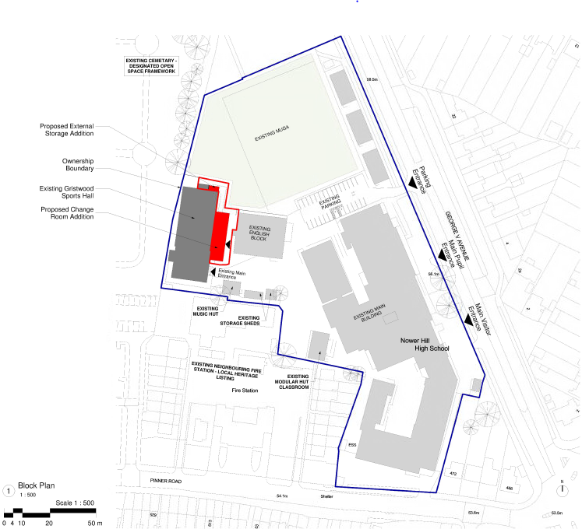

LOCATION PLAN

LONDON BOROUGH OF HARROW
PLANNING COMMITTEE
2nd September 2020

APPLICATION NUMBER: | P/1190/20
VALID DATE: | 10TH JUNE 2020
LOCATION: | NOWER HILL HIGH SCHOOL GEORGE V AVENUE
WARD: | PINNER
POSTCODE: | HA5 5RP
APPLICANT: | MRS AARTI SHAH
AGENT: | ARCADIS
CASE OFFICER: | SHAMAL LONDON
EXPIRY DATE: | 17th JULY 2020

PROPOSAL

Single storey front and side extension to sports hall building.

RECOMMENDATION

The Planning Committee is asked to:

- Agree the reasons for approval as set out in this report, and

- Grant planning permission subject to the conditions listed in Appendix 1 of this report.

REASON FOR THE RECOMMENDATION

The form, scale and siting of the proposed extension is appropriate in this location and does not appear at odds with the existing character of development in the immediate area and would not have an adverse impact on the amenity of the occupiers of adjoining properties in accordance with Policies 7.4B and 7.6B of The London Plan (2016) and Policy DM1 of the DMP (2013).

INFORMATION
This application is reported to Planning Committee as it would provide an extension to a school in excess of 100m² floorspace, on land where the Council holds an interest. The application is therefore referred to the Planning Committee as it does not fall within any of the provisions set out at paragraphs 1(a) – 1(h) of the Scheme of Delegation dated 12th December 2018.

Statutory Return Type: | E13 Minor Dwellings
Council Interest:  Net additional Floorspace: | Council has ownership of land in subject application  200 sqm
GLA Community Infrastructure Levy (CIL) Contribution (provisional): | N/A
Local CIL requirement: | N/A

HUMAN RIGHTS ACT
The provisions of the Human Rights Act 1998 have been taken into account in the processing of the application and the preparation of this report.
EQUALITIES
In determining this planning application the Council has regard to its equalities obligations including its obligations under section 149 of the Equality Act 2010.
For the purposes of this application there are no adverse equalities issues.
S17 CRIME & DISORDER ACT
It is considered that the proposed development would not adversely impact upon community safety issues or conflict with development plan policies in this regard.

- SITE DESCRIPTION

  - Nower Hill High School fronts both George V Avenue and Pinner Road.

  - The main school buildings are clustered at the south of the site between the main entrance on George V Avenue and the service entrance on Pinner Road.

  - The playing field is to the north of the main school buildings. It is bounded on the south by a sports hall (the subject site).

  - To the east, the field is bounded by three temporary classrooms (which are near George V Avenue). To the north of the field is a fenced area containing six tennis courts, and to the west is Pinner Cemetery.

  - Nower Hill High School is sited in the setting of the Pinner Road Conservation Area and the locally listed fire station. It is also located within a designated open space area. The site is located with a Surface water Zone.

- PROPOSAL

  - The application proposes the construction of single storey side and front extensions to the Sports Hall Building.

  - The proposed front extension would span 26.5 metres along the east elevation of the sports hall and would measure 7.14 metres in depth. It would be of a single storey and have a flat roof with a maximum height of 4.42 metres.

  - It would have two doors along the front elevation and window that would match the existing.

  - A new proposed external storage addition would be located along the northern elevation, This in essence would be an infill extension it would have a flat roof with a maximum height of 3.15 metres and a would be 2.72 metres wide. It would have a flat roof and would also be at ground floor level.

- RELEVANT PLANNING HISTORY

3.1 A summary of planning history is set out below:
Ref no. | Description | Status & date of decision
P/2645/08 | Retention of two temporary classrooms for two years to northern side of school  Grant | Granted 21ST November 2008
P/2203/12 | Part replacement of boundary fence and gates fronting George V Avenue with 1.95m high steel fence. | Granted 05th October 2012
P/1615/12 | Replacement of natural turf playing field with tiger turf grass playing field and related external alterations | Granted 9th August 2012
P/2824/13 | Variation of condition 2 of planning permission p/2156/09 dated 06-nov-2009 to allow the retention for an additional three years of two two-storey temporary buildings to provide classrooms. | Granted 17th December 2012

- CONSULTATION

4.1 A total of 69 consultation letters were sent to neighbouring properties regarding this application.

4.2 The overall public consultation period expired on 8th July 2020. No representations were received.

4.3 Statutory and Non Statutory Consultation

4.4 A summary of the consultation responses received along with the Officer comments are set out in the table below.

LBH Drainage
Can confirm that the FRA with Drainage Strategy submitted seems fine, however the following details are still required and can be conditioned.

- The applicant should submit a detailed drainage design in line with our standard requirements attached.
- The applicant should consult Thames Water developer services by email: developer.services@thameswater.co.uk or by phone: 0800 009 3921 or on Thames Water website www.developerservices.co.uk regarding capacity of their public sewers for receiving discharge from the proposed development. The Thames Water confirmation letter should be submitted.
- Permeable paving construction details and their maintenance plan should be submitted.

Please be informed that the requested details can be conditioned, attached are our standard drainage conditions/ informative for reference.

CAAC
No objection. (note: The D & A refers to the Pinner Road Conservation Area but the Heritage Statement does not include it.)
Conservation Officer
The single storey extension would be tucked away in relation to the heritage assets. As long as materials and details are conditioned to match, this would preserve the setting of this heritage asset.

Policy
In favour of the scheme, it is supporting enhanced education facilities. This would find favour with Policy S3 (Education and childcare facilities) and S5 (Sports and recreation facilities), and DM47B of the HDMP (2013). Furthermore, the location of the proposed new build does appear to be in the logical place, by reason of being located between the existing buildings, rather than being on the other side and projecting into the un-developed area of the school which is also in the designated open space.

5.0 POLICIES

5.1 Section 38(6) of the Planning and Compulsory Purchase Act 2004 requires that:

‘If regard is to be had to the Development Plan for the purpose of any determination to be made under the Planning Acts, the determination must be made in accordance with the Plan unless material considerations indicate otherwise.’

5.2 The Government has issued the National Planning Policy Framework [NPPF 2019] which sets out the Government’s planning policies for England and how these should be applied, and is a material consideration in the determination of this application.

5.3 In this instance, the Development Plan comprises The London Plan 2016 [LP] and the Local Development Framework [LDF]. The LDF comprises The Harrow Core Strategy 2012 [CS], Harrow and Wealdstone Area Action Plan 2013 [AAP], the Development Management Policies Local Plan 2013 [DMP], the Site Allocations Local Plan [SALP] 2013 and Harrow Local Area Map 2013 [LAP].

5.4 While this application has been principally considered against the adopted London Plan (2016) policies, some regard has also been given to relevant policies in the Draft London Plan (2019), as this will eventually replace the current London Plan (2016) when adopted and forms part of the development plan for the Borough.

5.5 The document was originally published in draft form in December 2017 and subject to Examination in Public (EiP) with the Panel’s report published in October 2019. The Mayor of London has considered these recommendations, and has either accepted them or where not, provided justification as to why accepting them would not be appropriate. The Mayor has now submitted to the Secretary of State an ‘Intend to Publish’ version of The Plan. It is for the Secretary of State to determine whether he agrees with the revised Plan and it ought to be published in that form.

5.6 The Draft London Plan is a material planning consideration that holds significant weight in determining planning applications, with relevant polices referenced within the report below and a summary within Informative 1.

6.0 ASSESSMENT

6.1 The main issues are:

- Principle of Development
- Character and Appearance of the Area/Setting of Conservation Area
- Residential Amenity
- Development and Flood Risk

6.2 Principle of Development
The relevant policies are:
    - National Planning Policy Framework (2019)
    - The London Plan (2016): 3.18 and 7.3
    - The Draft London Plan (2019): S3 and S5
    - Harrow Core Strategy 2012: CS1
    - Harrow Development Management Polices Local Plan (2013): DM1, DM18, DM46 and DM47

6.2.1 Policy DM46 of the Harrow Development Management Policies Local Plan (2013) supports the provision of new educational facilities subject to compliance with Policy DM1. Whilst Policy DM47(B) of the Harrow Development Management Policies Local Plan (2013) supports proposals that secure enhanced re-provision of educational facilities on site.

6.2.2 The proposed development is located within designated open space. Policy DM18 of the Development Management Policies Local Plan (2013) seeks to protect open space. It states that proposals for ancillary development on designated space will be supported when the proposal would be ancillary to the use of the open space, would be of an appropriate scale and where it would be ancillary to the use of the host building. The proposed extension to the sports building would be appropriate in scale and would not detract from the open character of the site or its surroundings.

6.2.3 The proportionate addition would be subordinate to the sports related use of the open space and therefore would be supported by Policy DM18 of the Development Management Policies Local Plan (2013). Therefore, the principle of the proposed extension is considered to be acceptable.

6.2.4 The proposal would not harm the ability of the site to continue as an educational institution, it is considered to be in accordance with policy 3.18 of the London Plan, S3 and S5 of the Intend to Publish Draft London Plan and Development Management Policies Local Plan (2016) and in line with Policy DM46 of the Development Management Policy.

6.3 Character and Appearance of the Area/Setting of Conservation Area
6.3.1 The relevant policies are:
- The National Planning Policy Framework (2019)
- The London Plan (2016): 7.4B, 7.6B, 7.8C and 7.8D
- The Draft London Plan Intend to Publish Version (2019): D1, D4 and HC1
- Harrow Core Strategy (2012): CS1B
- Harrow Development Management Policies (2013): DM1 and DM7

6.3.2 Nower Hill High School is sited in the setting of the Pinner Road Conservation Area and the locally listed fire station. The special character and appearance of this area is outlined by the Pinner Road Conservation Area Appraisal and Management Strategy and relates to the Art Deco metroland character and medium density layout.

6.3.3 The proposed development would be sited within the middle of the school complex, and, being single storey, it would not exceed the heights of the surrounding buildings. The proposal would be of a scale subordinate to the main buildings and due to its siting in the middle of the main complex would not appear discordant or obtrusive in its surrounding environment.

6.3.4 While it is noted the extension would reduce the gap between the host building and the main school ‘English Block’, it would still maintain a gap of 4 metres. The addition of the rear extension is not considered to be out of keeping with the character of the extension within the curtilage of the school, nor would it be out of keeping with the wider character of the area. With regard to the single storey side extension, this would be a proportionate addition which in essence would be an infill extension used for storage. It would have an acceptable impact to the character and appearance and would not impact on the openness of the area.

6.3.5 Moreover, the proposed single storey extension would be tucked away in relation to the heritage assets. As long as materials and details are conditioned to match existing, this would preserve the setting of this heritage asset. A condition has been added to ensure this.

6.3.6 In conclusion, it is considered that the proposal would have an acceptable impact on the character and appearance of Nower Hill High School and the wider area in accordance with the NPPF (2019), Harrow Core Strategy (2012) CS1.B, policies 7.4.B, 7.6.B and 7.8 C/D of The London Plan, policy D1 and D4 of the Draft London Plan (2019) – Intend to Publish version and policies DM1 and DM7 of the Development Management Local Plan Policies (2013).
6.4 Residential Amenity
6.4.1 The relevant policies are:
- National Planning Policy Framework (2019)
- The London Plan (2016): 7.6B
- The Draft London Plan (Intend to Publish Version) (2019): D3
- Harrow Core Strategy (2012): CS1
- Harrow Development Management Policies (2013): DM1

6.4.2 Due to its siting, modest design and largely buffered by the host building, it is considered that it would have no undue impact on neighbouring amenity of the area.

6.4.3 The proposal would be in accordance with London Plan policy 7.6B and policy DM1 of the Development Management Policies Local Plan (2013).

6.5 Development and Flood Risk
6.5.1 The relevant policies are:
- National Planning Policy Framework (2019)
- The London Plan (2016): 5.13
- The Draft London Plan (Intend to Publish Version) (2019): SI13
- Harrow Core Strategy (2012): CS1
- Harrow Development Management Policies (2013): DM9 and DM10

6.5.2 Policy DM9 B of the Development Management Policies Local Plan (2013) states, “proposals that would fail to make appropriate provision for flood risk mitigation, or which would increase the risk or consequences of flooding, will be refused.”
6.5.3 The proposed development would adjoin the surface water flood zone, the applicant has provided a Flood Risk Assessment which was deemed adequate and sufficient by the Drainage Engineer. It is considered the development would have an acceptable impact. As such this permission contains an informative relating to the provision of sustainable drainage systems, further a condition has been attached for the applicant to submit a detailed drainage design in line with the LPA’s standard requirements.

7.0 CONCLUSIONS AND REASONS FOR APPROVAL
7.1 The proposed development would provide a satisfactory, layout and design as to not detract from the host building. It is considered that the proposed building would have an acceptable design and external appearance and would not have an undue impact on the character and appearance of the area, the setting of the conservation area, the setting of the locally listed fire station or the residential amenity of neighbouring occupiers. The development would accord with development plan policies and is recommended for approval.

APPENIDIX 1: CONDITIONS AND INFORMATIVES

CONDITIONS:

- Timing

The development hereby permitted shall be begun before the expiration of three years from the date of this permission.
REASON: To comply with the provisions of Section 92 of the Town and Country Planning Act 1990.

- Approved plans and documents

The development hereby permitted shall be carried out, completed and retained in accordance with the following approved plans and document: 10021828-ARC-01-GF-DR-AR-001 Revision A; 10021828-ARC-01-GF-DR-AR-002 Revision C; 10021828-ARC-XX- GF-DR-AR-03 Revision E; 10021828-ARC-XX- GF-DR-AR 04 Revision M; 10021828-ARC-XX- GF-DR-AR-05 Revision J; 10021828-ARC-XX-RF-DR-AR-06 Revision E; 10021828-ARC-XX- GF-DR-AR-07 Revision A; 10021828-ARC-XX- RF-DR-AR-08 Revision A; 23868UG-01; Flood Risk Assessment; Geospehere Environmental Report (dated 19th February 2019); Archaeological Assessment; Design and Access Statement

REASON: For the avoidance of doubt and in the interests of proper planning.

- Materials

The materials to be used in the construction of the external surfaces of the extension hereby permitted shall match those used in the existing building.
REASON: To safeguard the character and appearance of the area.

INFORMATIVES:

            - Policies

The following policies are relevant to this decision:

The National Planning Policy Framework 2019

The London Plan 2016

3.18, 7.3B, 7.4B, 7.6B, 7.8C and D

Draft London Plan Intend to Publish Version 2019
D1; D3, HC1, S3, S5

The Harrow Core Strategy 2012
CS1.B

Harrow Development Management Policies Local Plan 2013
DM1, DM7, DM9, DM10, DM18 DM46

Relevant Supplementary Planning Document
Supplementary Planning Document: Residential Design Guide (2010)
Pinner Road Conservation Area Appraisal and Management Strategy
Locally Listed Buildings SPD
Historic England Good Practice Advice in Planning Note 3: The setting of heritage assets

- Considerate Contractor code of practice

The applicant's attention is drawn to the requirements in the attached Considerate Contractor Code of Practice, in the interests of minimising any adverse effects arising from building operations, and in particular the limitations on hours of working.

- Sustainable Urban Drainage

The applicant is advised that surface water run-off should be controlled as near to its source as possible through a sustainable drainage approach to surface water management (SUDS). SUDS are an approach to managing surface water run-off which seeks to mimic natural drainage systems and retain water on or near the site as opposed to traditional drainage approaches which involve piping water off site as quickly as possible. SUDS involve a range of techniques including soakaways, infiltration trenches, permeable pavements, grassed swales, ponds and wetlands. SUDS offer significant advantages over conventional piped drainage systems in reducing flood risk by attenuating the rate and quantity of surface water run-off from a site, promoting groundwater recharge, and improving water quality and amenity. Where the intention is to use soak ways they should be shown to work through an appropriate assessment carried out under Building Research Establishment (BRE) Digest 365. Support for the SUDS approach to managing surface water run-off is set out in the National Planning Policy Framework (NPPF) and its accompanying technical guidance, as well as the London Plan. Specifically, the NPPF (2012) gives priority to the use of sustainable drainage systems in the management of residual flood risk and the technical guidance confirms that the use of such systems is a policy aim in all flood zones. Policy 5.13 of the London Plan (2012) requires development to utilise sustainable drainage systems unless there are practical reasons for not doing so. Sustainable drainage systems cover the whole range of sustainable approaches to surface drainage management. They are designed to control surface water run-off close to where it falls and mimic natural drainage as closely as possible. Therefore, almost any development should be able to include a sustainable drainage scheme based on these principles.

The applicant can contact Harrow Drainage Section for further information.

6. Surface and foul water connections
The applicant is advised that the Drainage Authority in Harrow recommends the submission of a drainage plan, for their approval, indicating all surface and foul water connections and their outfall details. Please also note that separate systems are used in Harrow for surface water and foul water discharge. Please email infrastructure@harrow.gov.uk with your plans.

7. Damage to Highway
The applicant is advised to ensure that the highway is not interfered with or obstructed at any time during the execution of any works on land adjacent to a highway. The applicant is liable for any damage caused to any footway, footpath, grass verge, vehicle crossing, carriageway or highway asset. Please report any damage to nrswa@harrow.gov.uk or telephone 020 8424 1884 where assistance with the repair of the damage is available, at the applicants expense. Failure to report any damage could result in a charge being levied against the property.

CHECKED
Interim Chief Planning Officer | Orla Murphy pp Beverley Kuchar 20.8.20
Corporate Director | Orla Murphy pp Beverley Kuchar 20.8.20

APPENDIX 2: LOCATION PLAN

APPENDIX 3: SITE PHOTOGRAPHS
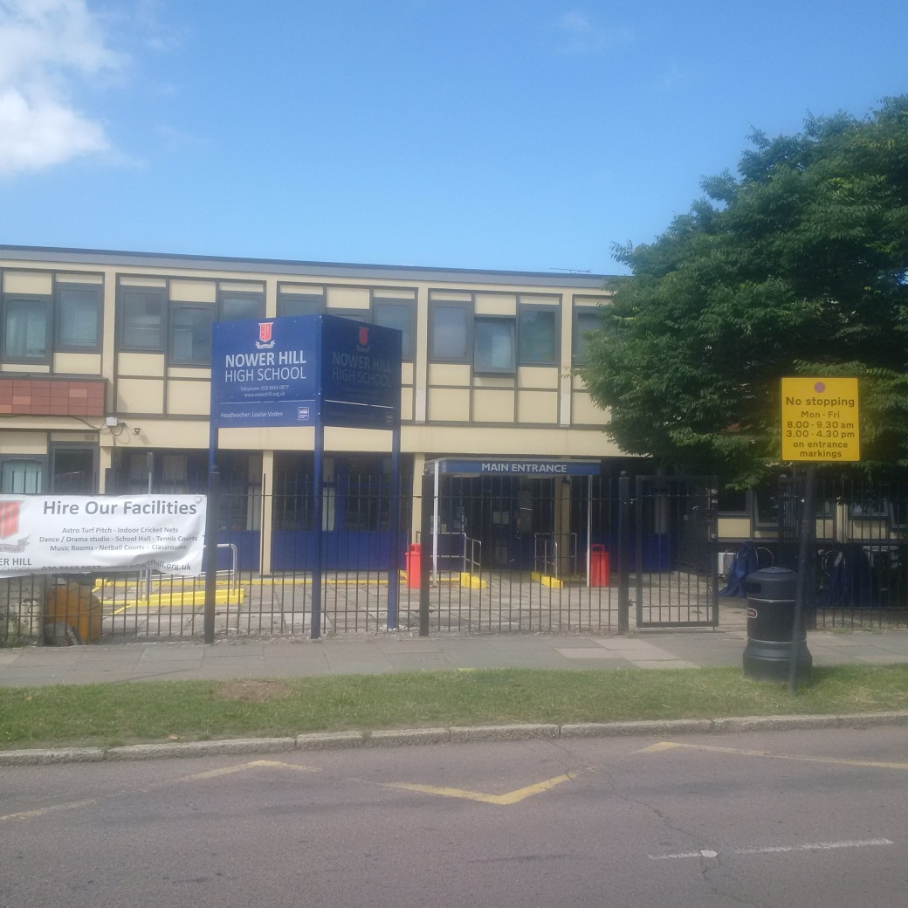

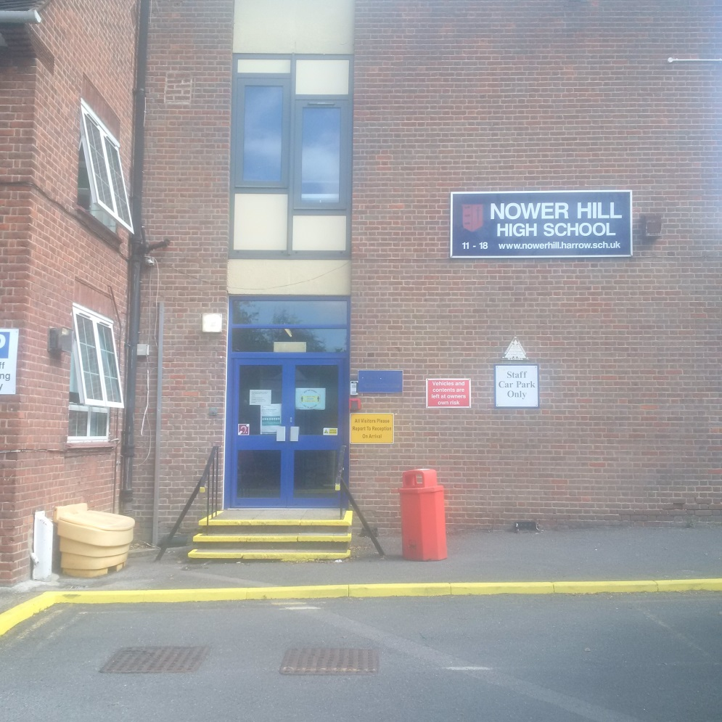

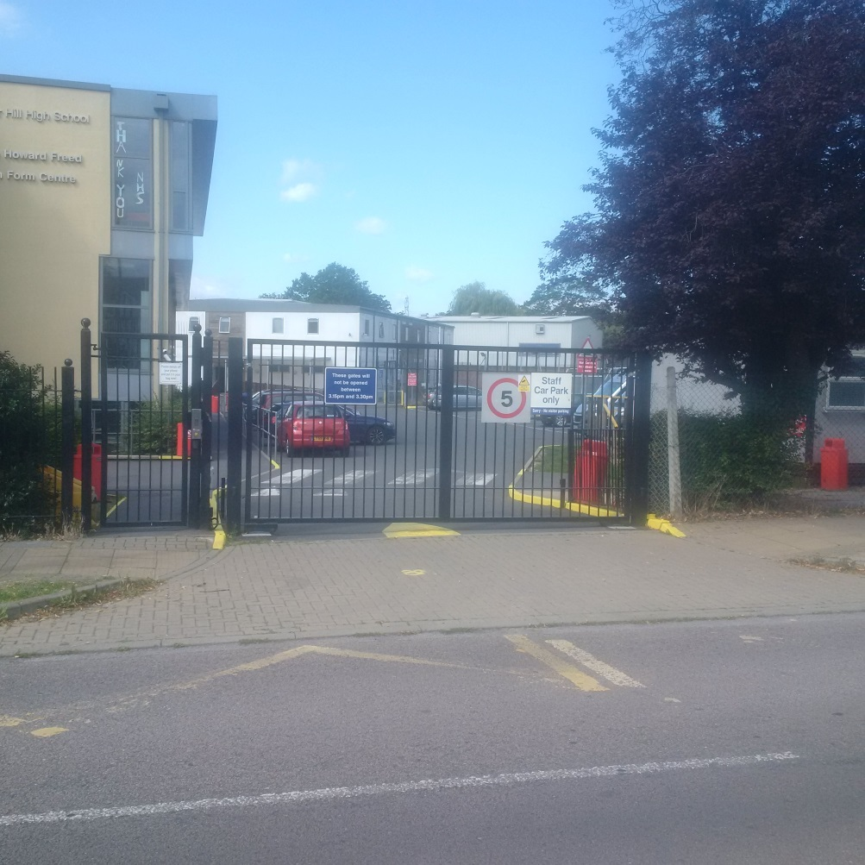

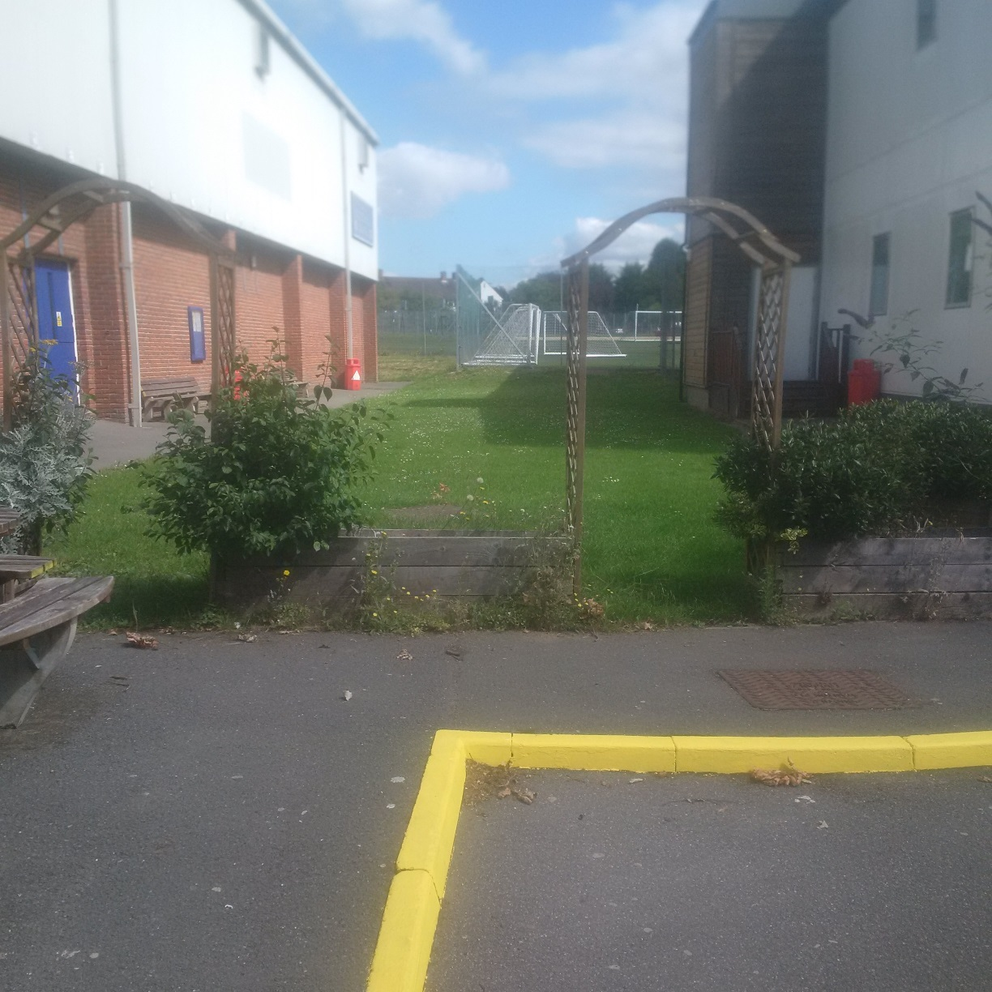

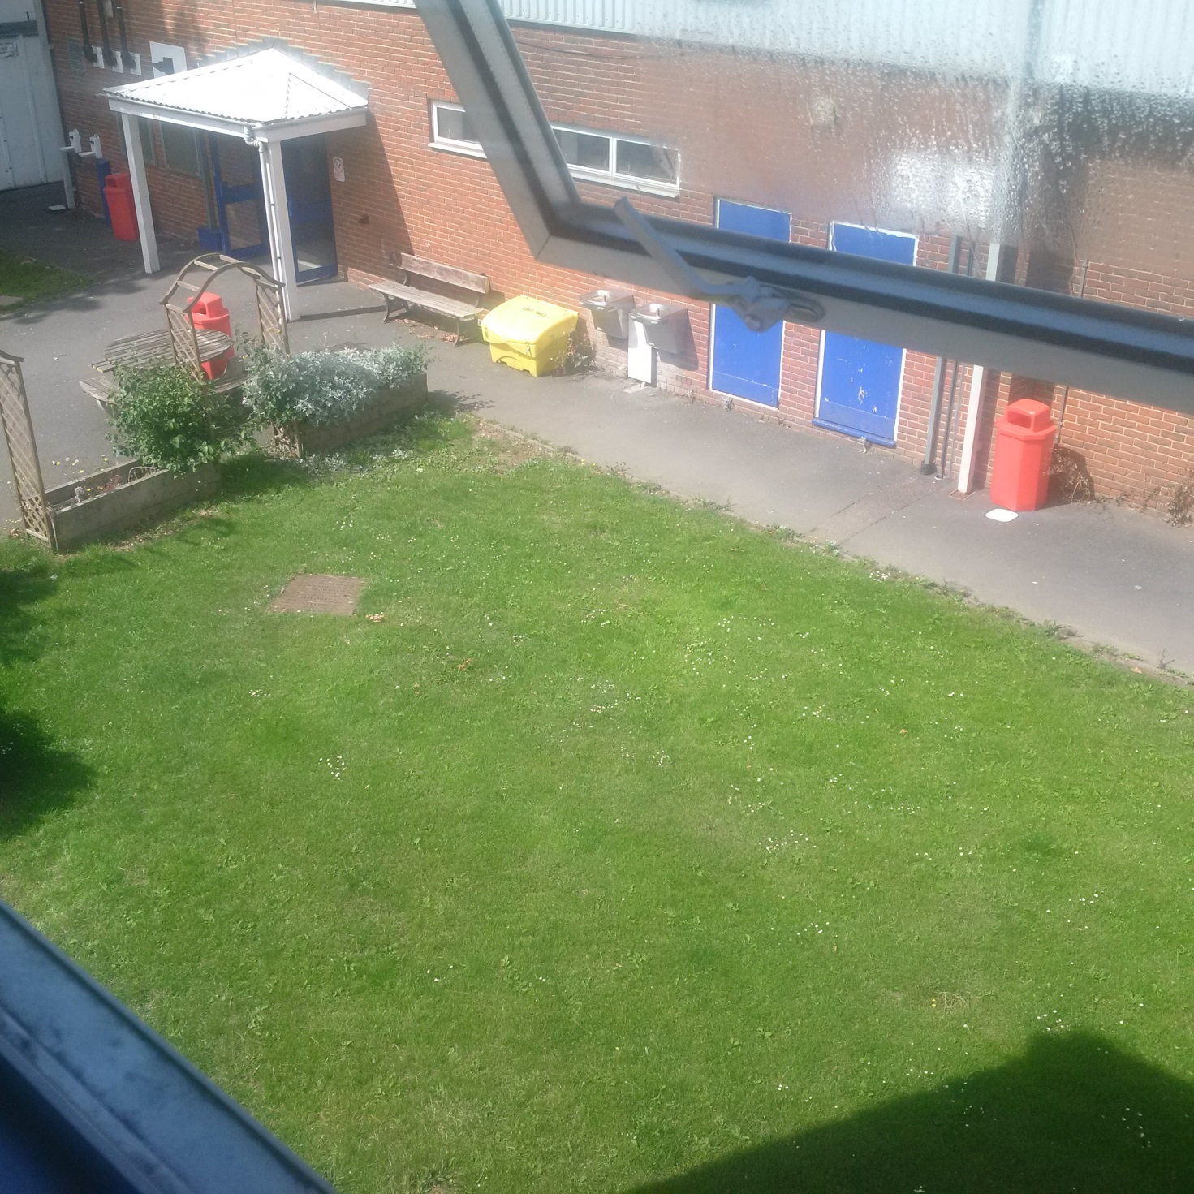

APPENDIX 4: PLANS AND ELEVATIONS
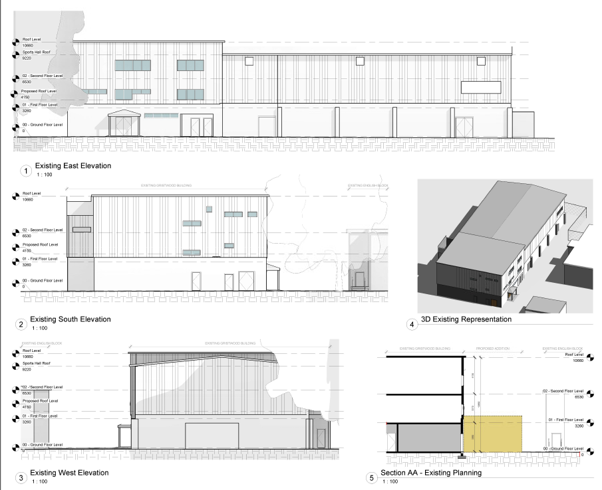
Figure 1 Existing Elevation

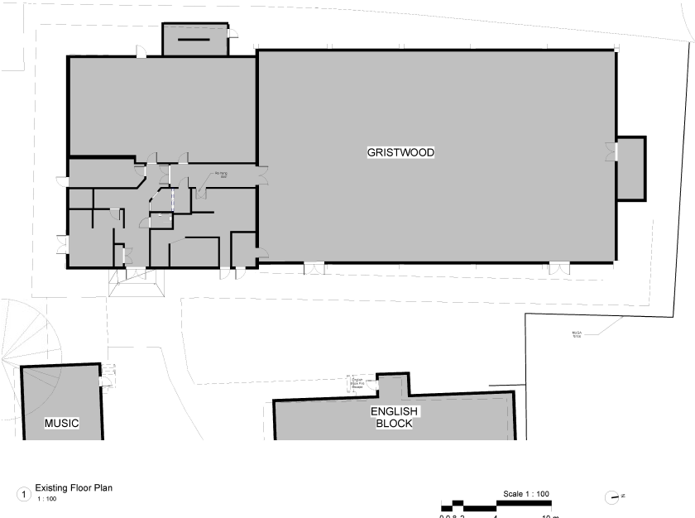

Figure 2 Existing Floor Plan

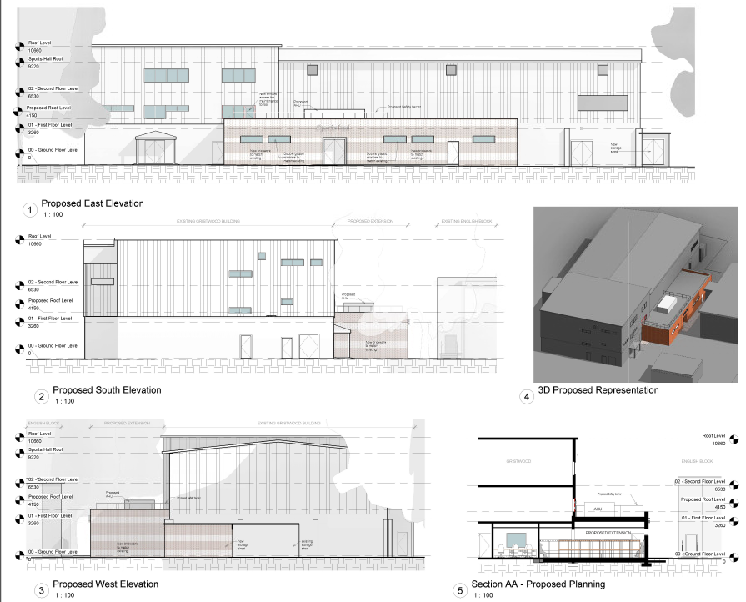
Figure 3 Proposed Elevation
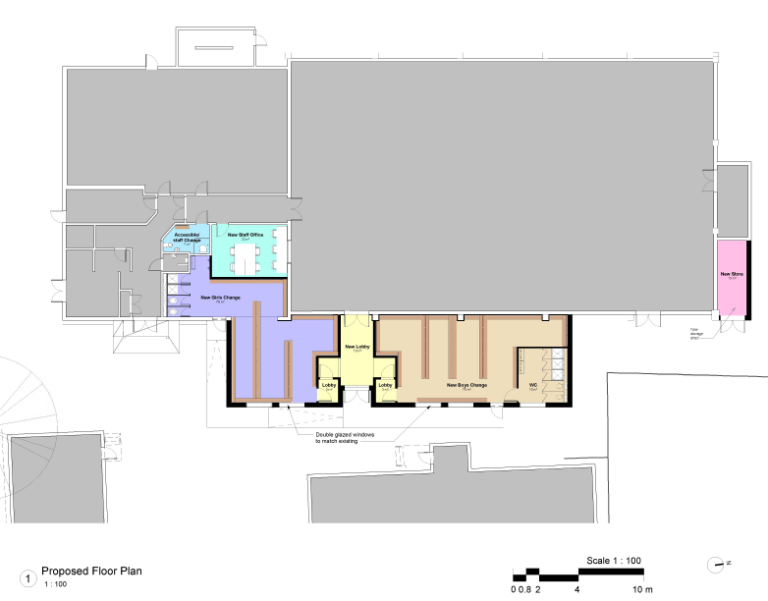
Figure 4 Proposed Floor Plan

